ML-Based Adaptive Solar Energy Management System for Optimized Battery Health and Efficiency



By
Najam Shahbaz
SAP Id: 26866

Maha Masood Abbasi
SAP Id: 35429

Nouman Sameer
SAP Id: 35811

Final Year Project Report

Department of Electrical Engineering/Biomedical Engineering
Riphah International University, Pakistan

Spring 2025

 | Riphah International University  Pakistan

ML-Based Adaptive Solar Energy Management System for Optimized Battery Health and Efficiency

A Thesis Presented to

Riphah International University, Pakistan

In partial fulfillment
Of the requirement for the degree of

B.S. Electrical Engineering

By
Najam Shahbaz
SAP ID: 26866

Maha Masood Abbasi
SAP ID: 35429

Nouman Sameer
SAP ID : 35811

Declaration

We, hereby, declare that this project, neither as a whole nor as a part thereof has been copied out from any source. It is further declared that we have developed this project and the accompanying report entirely based on our personal efforts made under the sincere guidance of our supervisor. No portion of the work presented in this report has been submitted in support of any other degree or qualification of this or any other University or Institute of learning; if found, we shall stand responsible.
Signature:______________
Name: Najam Shahbaz
Signature:______________
Name: Maha Masood Abbasi
Signature:______________
Name: Nouman Sameer

Riphah International University, Pakistan
Spring 2025


Department of Electrical/Biomedical Engineering
Riphah International University, Pakistan

The project ML-Based Adaptive Solar Energy Management System for Optimized Battery Health and Efficiencypresented by:

Najam Shahbaz
SAP ID: 26866

Maha Masood Abbasi
SAP ID: 35429

Nouman Sameer
SAP ID: 35811

under the supervision of their project advisor and approved by the project examination committee, has been accepted by the Riphah International University, Pakistan, in partial fulfillment of the requirements for the four-year degree of B.S. Electrical/Biomedical Engineering.

(Supervisor Name)
Designation, Project Advisor

(Dr.Sohail Khalid )
Associate professor & HOD
Department of Electrical
Dedication
This thesis is dedicated to our parents, siblings, and spouse, for always believing in us, inspiring us, and encouraging us to reach higher in order to achieve our goals. Without them, none of this would have been possible. Their confidence in us has sustained my enthusiasm and upbeat attitude throughout this process.

Acknowledgement
All honor and glory belong to the Almighty Allah, who granted me the fortitude and perseverance to complete this task. This project would not have been completed without the guidance of my supervisor Dr. Sadiq Orakzai and our co-supervisor Dr Farrukh Qureshi. Their consistent help, motivation, and guidance left no stone unturned to give this idea a concrete shape.

Table of Contents
1. Introduction
  - History of weather prediction using ML ……………………………….1

  - Project Introduction ………………………………………………….1

  - Project Scopes and outcomes ……………………………………………1

  - Project flow diagram …………………………………………………2

- Literature Survey

  - . Methods used for weather prediction………………………………….

  - Results of ML prediction of weather ………………………………….

- Software Implementations

  - ML model for weather prediction………………………………………

3.1.1 Dataset …………………………………………………………

  - Components …………………………………………………

  - Components Specification and their output …………………………….

- Modelling and Simulation ……………………………………………………

- Hardware fabrication, Testing and Results …………………………………….

- Future Work ……………………………………………………………….

- Summary ………………………………………………………………………

List Of Figures:

Abstract:

Chapter 01:
Introduction:
With solar power emerging as one of the most widely used technologies, the global energy

landscape has seen a significant shift in recent years toward sustainable and renewable energy

sources. However, the effective management of energy generation and storage components is

crucial to the dependability and efficiency of solar energy systems. Among these, battery storage

systems are essential for maintaining grid independence and a steady power supply. Sadly, issues

like battery deterioration, wasteful energy use, and erratic environmental conditions frequently

impair these systems' long-term functionality. In order to improve the lifespan and operational

efficiency of battery systems in solar setups, this project suggests an adaptive solar energy

management system based on machine learning (ML). This system dynamically learns and

adjusts to real-time energy consumption patterns, weather information, and battery health

indicators, in contrast to conventional energy management methods that depend on static rules or

manual configuration. The system can make wise choices about energy distribution, charging

\cycles, and load prioritization by utilizing machine learning algorithms, especially predictive

models and reinforcement learning techniques. Better performance and longer battery life are the

outcomes of a more intelligent energy flow that minimizes waste and battery stress. In order to

proactively optimize energy allocation, the system also incorporates important environmental

inputs like temperature, solar irradiance, and usage forecasts. This strategy is particularly useful

in off-grid or hybrid power situations where supply and demand must be balanced. The project

shows how data-driven decision-making can greatly surpass traditional energy management

systems in terms of efficiency and dependability through simulations and prototype testing. This

project advances the larger objective of creating robust, independent, and intelligent solar energy

infrastructures by tackling sustainability and technological innovation. It has great potential for

use in remote-area, industrial, and residential energy systems, laying the groundwork for

upcoming developments in green technology and intelligent energy management.

1.2: History:

Numerical weather prediction (NWP) models, which use physical equations to simulate the atmosphere, were a major component of traditional weather forecasting. These models are sensitive to initial conditions and demand a lot of processing power.
A change started as big data and machine learning grew in popularity:

- Early Machine Learning in Weather Prediction (2000s–2010s):

To forecast temperature, wind speed, or rainfall, models such as support vector machines (SVMs), decision trees, and random forests were employed.
ML provided predictions more quickly than conventional models, but because of its basic architectures and small datasets, its accuracy was limited.
- Emergence of Deep Learning (2015–Present):
Convolutional Neural Networks (CNNs) and Recurrent Neural Networks (RNNs), particularly LSTMs, are deep learning models that have gained popularity for forecasting intricate weather patterns.
Large, high-dimensional datasets like satellite photos and time-series climate data are excellent learning sources for these models.
Accuracy and generalizability were enhanced by the emergence of hybrid approaches that combined machine learning with physical models.

Link to Predict Battery Health:
Similar to weather systems, battery health entails dynamic, complex, and non-linear behaviors that are challenging to simulate using physics alone. According to your table:
Similar to forecasting future weather based on historical data, Das & Kumar (2023) and Heinrich et al. (2023) use machine learning (ML) and neural networks to predict State of Health (SOH) and Remaining Useful Life (RUL).
To increase prediction robustness, Dineva et al. (2024) combine deep learning with control strategies (much like hybrid weather models).

ML is revolutionizing energy systems, especially in predicting and managing battery performance under changing environmental and load conditions. This is similar to how ML transformed weather forecasting by providing data-driven, adaptive models that supplement conventional physics-based approaches.

1.2 Project Introduction:

In order to solve the global energy crisis and environmental issues, it is now imperative that renewable energy technologies—especially solar power—be adopted quickly. The erratic and sporadic nature of solar irradiance, however, is one of the major drawbacks of solar energy systems and has a direct effect on the dependability and efficiency of power generation and storage. To ensure a stable and sustainable energy supply, it is essential to not only generate solar power efficiently but also to intelligently manage energy storage, particularly in lithium-ion batteries, which are widely used due to their high energy density and longevity.
This project presents an integrated solution combining machine learning-driven weather forecasting with smart battery energy management, aiming to improve the overall performance and durability of solar power systems. At the core of the system is an XGBoost regression model, a powerful machine learning algorithm known for its speed and accuracy, used to predict solar irradiance.
The model is trained using real-time sensor data and historical weather records, allowing it to generate highly reliable short-term forecasts of solar input. The predicted irradiance data is then fed into a solar energy management system, which optimizes the charging and discharging cycles of lithium-ion batteries.
By aligning energy storage behavior with anticipated solar availability, the system can effectively prevent overcharging and deep discharging, two major causes of battery degradation. This proactive strategy maintains the battery’s State of Charge (SOC) within safe operating limits and extends its State of Health (SOH) over time, leading to improved system efficiency, reliability, and lifespan.
Ultimately, this project demonstrates how machine learning can be leveraged to make renewable energy systems smarter and more adaptive, bridging the gap between data-driven prediction and real-world energy management. It not only contributes to the advancement of intelligent solar energy infrastructure but also aligns with the global push toward sustainable and self-sufficient energy solutions.

1.3 Project scopes and outcomes:
Project Scope:

- Machine Learning Integration with Renewable Energy
Utilize real-time and historical weather data to predict solar irradiance using machine learning algorithms (such as XG Boost).
- Flexible Battery Control:
Using predicted solar input, create intelligent control strategies to maximize battery charging and discharging cycles.
- . Monitoring the Health of Batteries:
Lithium-ion batteries' ideal State of Charge (SOC) and State of Health (SOH) should be tracked and maintained.

- Acquiring Data in Real Time:
Gather and analyze sensor data in real time, including voltage/current levels, temperature, and solar irradiance.
- Energy Scheduling Based on Prediction:
To optimize energy efficiency and avoid overcharging or deep discharging, use forecast-based decision-making.
- Validation and Simulation of the System:
Create a prototype or simulation model to verify the suggested system's functionality in various situations.

- Scalability and Useful Implementation:
Provide an adaptable framework.

Anticipated Results:

- Precise Prediction of Solar Irradiance:
Utilize the XGBoost regression model to improve energy planning by achieving high prediction accuracy.
- Longer Battery Life:
Avoid damaging charging practices to lessen battery stress and extend battery life.
- Enhanced Efficiency of the System:
Increase the efficiency of energy storage and power consumption, particularly in the face of erratic weather.
- Reduced Costs of Upkeep and Replacement:
Reduce the frequency of battery replacements by minimizing degradation and failures.
An intelligent and sustainable energy solution
Participate in the creation of more intelligent, self-regulating renewable energy systems.
- Data-Informed Decision Assistance:
Give useful information about energy consumption trends for upcoming improvements or expansion.
- Real-world Implementation Readiness:
Lay the groundwork for deployment in smart grids, remote microgrids, and green energy applications.

Chapter 2: Methodology
Purpose:
Chapter 2 focuses on the research approach, data handling, model development, and system design strategy. It answers how you planned and executed the research — from data collection to algorithm design, all before actual hardware implementation.

Suggested Subheadings for Chapter 2: Methodology

2.1 Research Design and Approach
- Overview of the hybrid approach: combining software (ML prediction) and hardware (energy system).
- Justification for using XGBoost for solar irradiance prediction.

2.2 Data Collection
- Source of historical weather data (mention 4 years’ dataset).
- Real-time data sources: sensors for temperature, humidity, LDR, wind, and rain.
- Data types and resolution.

2.3 Data Preprocessing
- Handling missing values and noise.
- Feature selection and engineering (e.g., lag features for time series).
- Normalization or standardization techniques.

2.4 Machine Learning Model Development
- Introduction to XGBoost regression.
- Training and validation process.
- Performance metrics used (RMSE, MAE, etc.).

2.5 System Design Methodology
- Strategy for integrating predictions with battery control.
- System logic for charging/discharging decisions based on solar forecasts.
- Software-hardware communication flow.

2.6 Tools and Technologies
- Software: Python, Jupyter Notebook, scikit-learn, XGBoost, Raspberry Pi OS.
- Hardware interface: GPIO programming, libraries used for sensor integration.

✅ Chapter 3: Prototype Development
Purpose:
Chapter 3 focuses on the actual hardware implementation, integration of all components, and how the prototype was physically constructed, tested, and configured.

Suggested Subheadings for Chapter 3: Prototype Development

3.1 System Architecture Overview
- Present the block diagram from your progress report.
- Explain the division of the system into hardware and software components.

3.2 Battery Pack Design
- Configuration: 3S9P with 27 Li-ion cells.
- Theoretical specs: voltage, capacity, and total power output.
- Safety considerations.

3.3 Battery Management System (BMS)
- Design and role of SOC and SOH circuits.
- PCB layout and testing process.
- Monitoring parameters and thresholds.

3.4 Sensor Integration
- List and describe sensors: DHT11 (temperature/humidity), LDR, rain sensor, wind sensor.
- Sensor placement and interfacing with Raspberry Pi.
- Calibration or signal conditioning if any.

3.5 Raspberry Pi and Control Logic
- Model used and OS.
- ML model deployment process.
- Relay/inverter control script logic.

3.6 Real-Time Prediction Workflow
- Flow of data: sensor → Raspberry Pi → prediction → control action.
- Decision-making process for energy management.

3.7 System Assembly and Testing
- Photos of the prototype (PCB, wiring, sensor placements).
- Issues encountered during testing (e.g., sensor delays, communication errors).
- How those issues were resolved.

RF Performance:
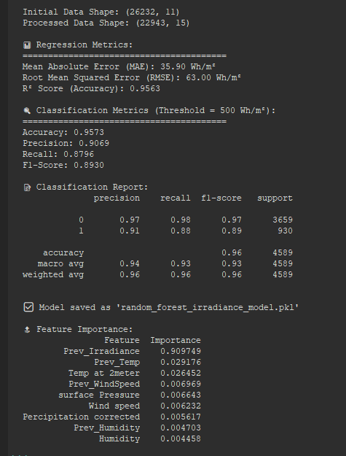

XGB Perfrmance
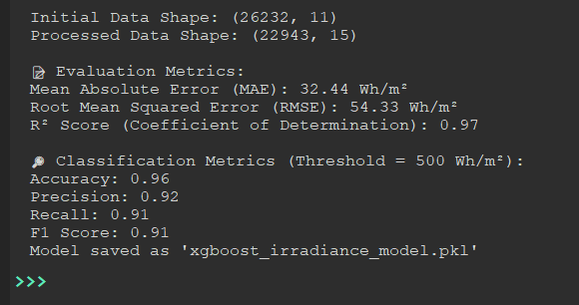

Pc817 optocupler

